**Welcome to Day #8 of CGCC!**

Every day we will have a GitHub repository page that outlines each day and the activities that we will complete. We will also provide all homework on these pages.

Feel free to browse the other days to see what is coming up!

As always, let us know if you need any help or have any questions.

*Link to Camp GitHub*:<https://github.com/paigerodeghero/ClemsonGameCodingCamp/tree/master/2021>

**Day 8: Movement and Projectiles**

**SCHEDULE:**

* Instructors start video call and recording
* Sharing Assets and progress (with Group)
* Finish discussion on movement with Makayla.
  + 10-minute breakout to catch up.
* Break
* Adding second character to Godot.
  + 10-minute breakout to catch up.
* Shooting projectiles
  + 10-minute breakout to catch up.
* Break
* Projectile collision and collision detection
  + 10-minute breakout to catch up **OR** Break
* Character deaths
  + 10-minute breakout to catch up.
* *If time:* Group Game Development
* Instructors end video call

**ACTIVITY: Game Asset / Progress Sharing** (10 minutes)

One person from each team shares an asset that they’re working on and update the camp on their game’s development progress.

Order of Teams:

* Group Sirius
* Group Vega
* Group Rigel
* Group Deneb
* Group Aldebaran

**ACTIVITY:** GoDot Development: Movement (Day 7 wrap up)

1. To move our character, since it’s a KinematicBody2D, we’ll need to use a function called _physics_process(delta). This function has physics already built in so we don’t have to worry about it. Add lines 16 - 18 to your script.

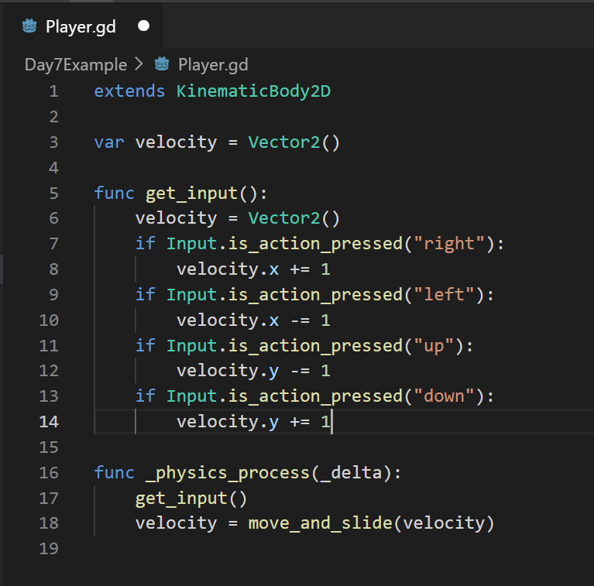

1. Now save your script, go back to GoDot, and play your game. You should see that your character **moves VERY slowly** since we’re only moving one pixel at a time. We can add a variable for speed and multiply our velocity by it to make the character move quicker. Add line 4 and 16 to your script.

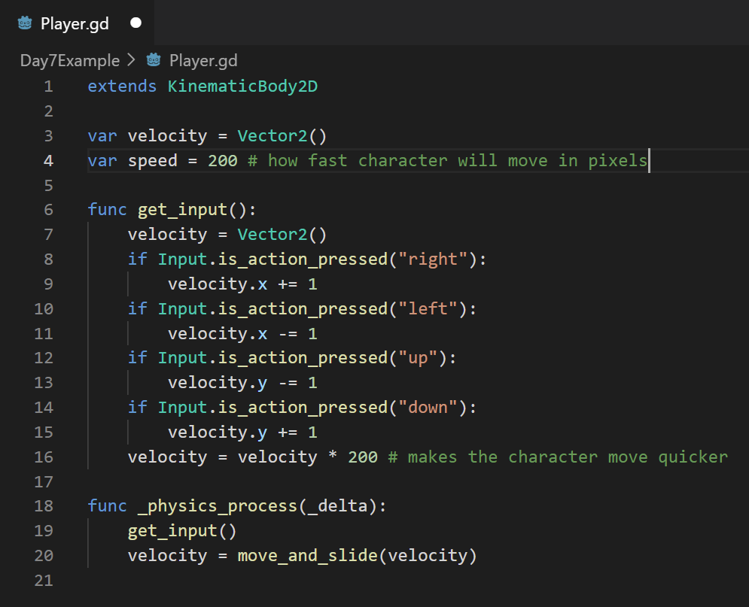

1. Lastly, if we hold the up and right keys, we will notice that the character moves faster in the diagonal direction than in the forward direction. We need to modify line 16 as follows:

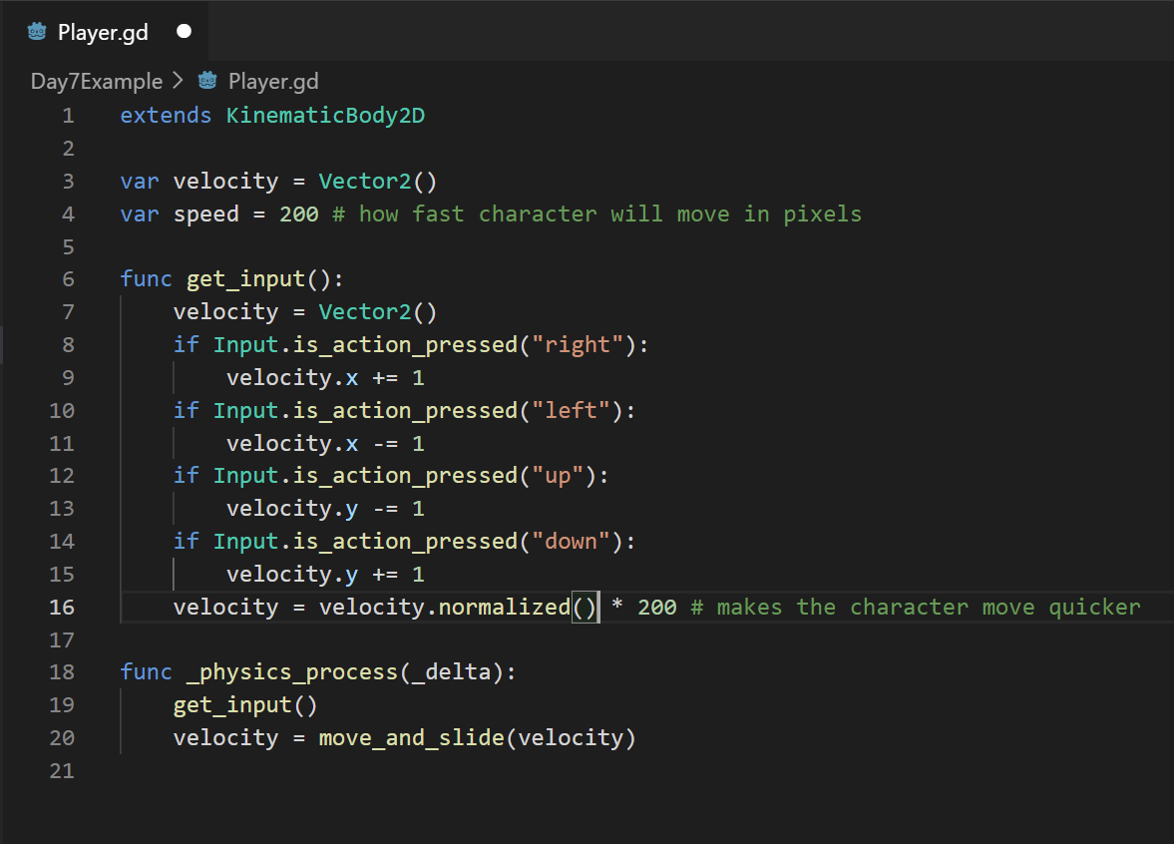

* 1. Which will make the character move the same speed in all directions.

Breakout room break?

**10-minute break**

**ACTIVITY:** GoDot Development: Adding a second character

**Step 1: creating the Enemy Scene**

1. Now we’re going to add a second character to the same game we started on day 7.

(You’ll need the work we did on day 7 and what we finished this morning, as well as 2 other sprites: an enemy sprite and a projectile sprite.)

* 1. What we’re going to do is create another scene. So at the top, click Scene -> New Scene
  2. Set the Root node as a 2D scene and save the scene as Enemy.tscn
  3. Right click the Node2D node in the Scene tab and click on **Change Type**
  4. 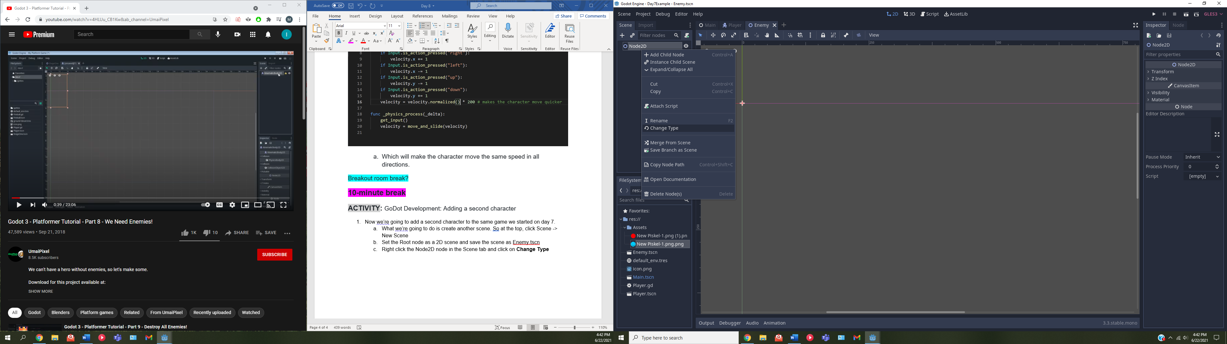
  5. Change the type to a **KinematicBody2D.**
  6. Rename the node to “**Enemy**”
  7. Add a **Sprite** node as a child of **Enemy**.
  8. In the FileSystem tab, drag your enemy sprite to the **Texture** field of the Sprite’s inspector
     1. This will have the sprite appear in the center of scene.

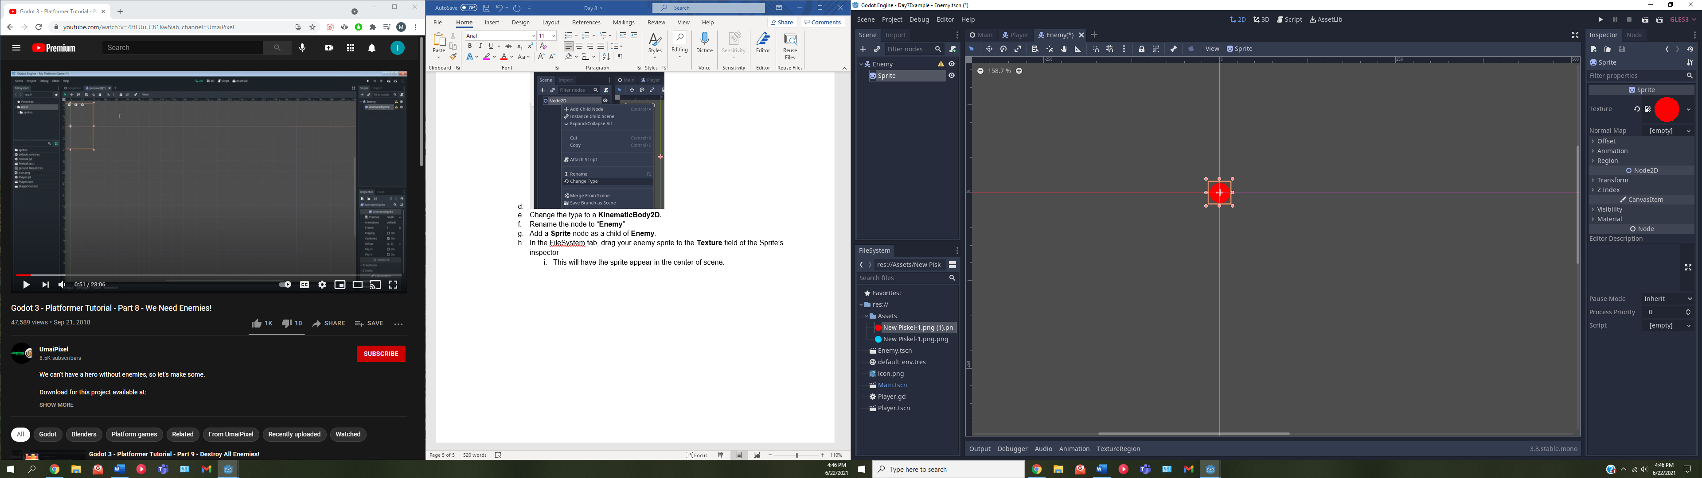

* 1. Add a **CollisionShape2D** node as a child of **Enemy**
  2. in the inspector of your **CollisionShape2D** change the shape to match your sprite. Mine is a red circle, so I’ll choose the circle shape.
  3. If needed, move and/or resize the collision box (the light blue box that appeared) to fit your sprite.
  4. Be sure to save your scene.
  5. Visually speaking, our second character is done. Notice this was the same thing we did on day 7. This is more or less how you’ll be adding most if not all of your sprites to your game.

Breakout room time if needed

**Step 2: Scripting the enemy to move up and down automatically**

1. Now we need to add a script to the enemy.
   1. Right click on **Enemy** in the scene tab and click on **Attach Script**.
   2. Let’s keep the default name.
   3. Once the script is created, open it up in VSCode. If it doesn’t appear, make sure Godot has been saved.
   4. Inside VSCode, let’s get rid of everything **Except line 1**.
   5. Let’s go ahead and create our **func _physics_process(delta)** function since we are going to have the enemy move. While we’re at it we can also create our **velocity** variable in the same way we did for the player.

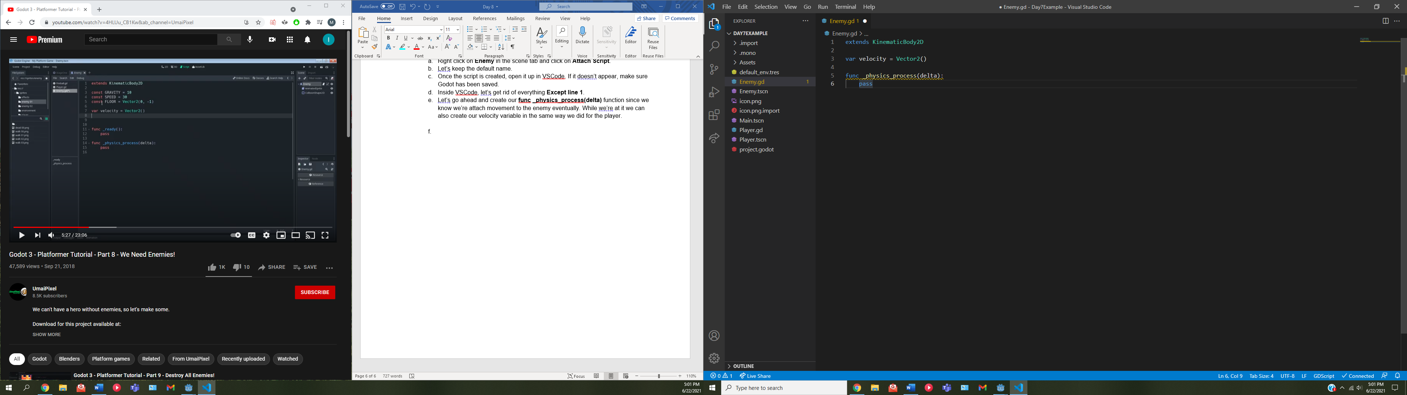

* 1. What we can do now, for demo purposes, is set the enemy to move up and down on our screen.
     1. To do this, we need to add a variable to our Enemy that lets the enemy know if it should be moving up or down. I’ll call the variable **movingUp** and set it equal to **true**.

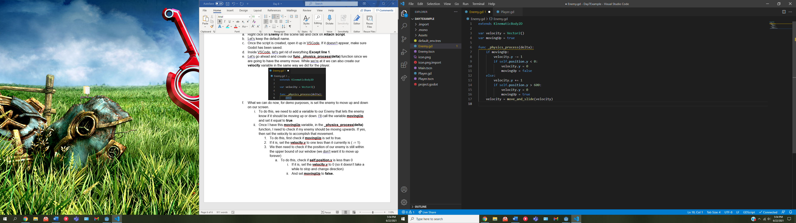

* + 1. Once I have this **movingUp** variable, in the **_physics_process(delta)** function, I need to check if my enemy should be moving upwards. If yes, then set the velocity to accomplish that movement.
       1. To do this, first check if **movingUp** is set to true.
       2. If it is, set the **velocity.y** to one less than it currently is ( -= 1)



* + - 1. We then need to check if the position of our enemy is still within the upper bound of our window (we don’t want it to move up forever)
         1. To do this, check if **self.position.y** is less than 0

If it is, set the **velocity.y** to 0 (so it doesn’t take a while to stop and change direction)

And set **movingUp** to **false.**



* + 1. Now that we have the upwards movement, we need to set the downwards.
       1. after the **if movingUp** block on line 7, we can then call **else:** on line 12. Booleans can only be true or false, so if line **movingUp** is set to false, our if statement “fails” and we go to the else block.
       2. If we’re inside the else block, it means we need to move down, so set the **velocity.y** equal to one greater ( += 1 )



* + - 1. We then need to check if we are still in the lower bound of our window (by default, Godot sets the window to have a lower bound of 600).
         1. To do this, check if **self.position.y** is greater than 600.

If it is, set the **velocity.t** to 0.

Set **movingUp** to **true**



* + 1. Finally, outside of the if/else block, on line 17 we set **velocity** equal to **move_and_slide(velocity)**. This will cause our enemy to move up and down the screen.



Breakout room if needed

**Step 3: Create the projectile scene**

1. Now we need to make the projectile our player is going to shoot
   1. Start by creating a 2D **projectile** scene.
   2. Create an **Area2D** node as the first node in the scene and rename it to **projectile.**
   3. much like with the player, we need to add a sprite. Add a **Sprite** node as a child to **projectile.**
   4. Attach the png of your projectile to the **Texture** field in the **Sprite’s** inspector.
   5. Then add another child node to **projectile**, this time a **collisionShape2D.**
   6. Go into the inspector for the **collisionShape2D** and set the **shape** field to whatever shape matches your projectile.
      1. Move and resize the collision box as you need.
   7. Now we need to add a script to **projectile.** Do this by right clicking on it in the scene tab and click on **attach script.** Keep the defaults when you create it.
   8. **Save your scene**
   9. Open up the projectile.gd in VSCode and delete everything **except line 1**
   10. Our projectile is going to move, so add the **func _physics_process(delta)** function to line 3.

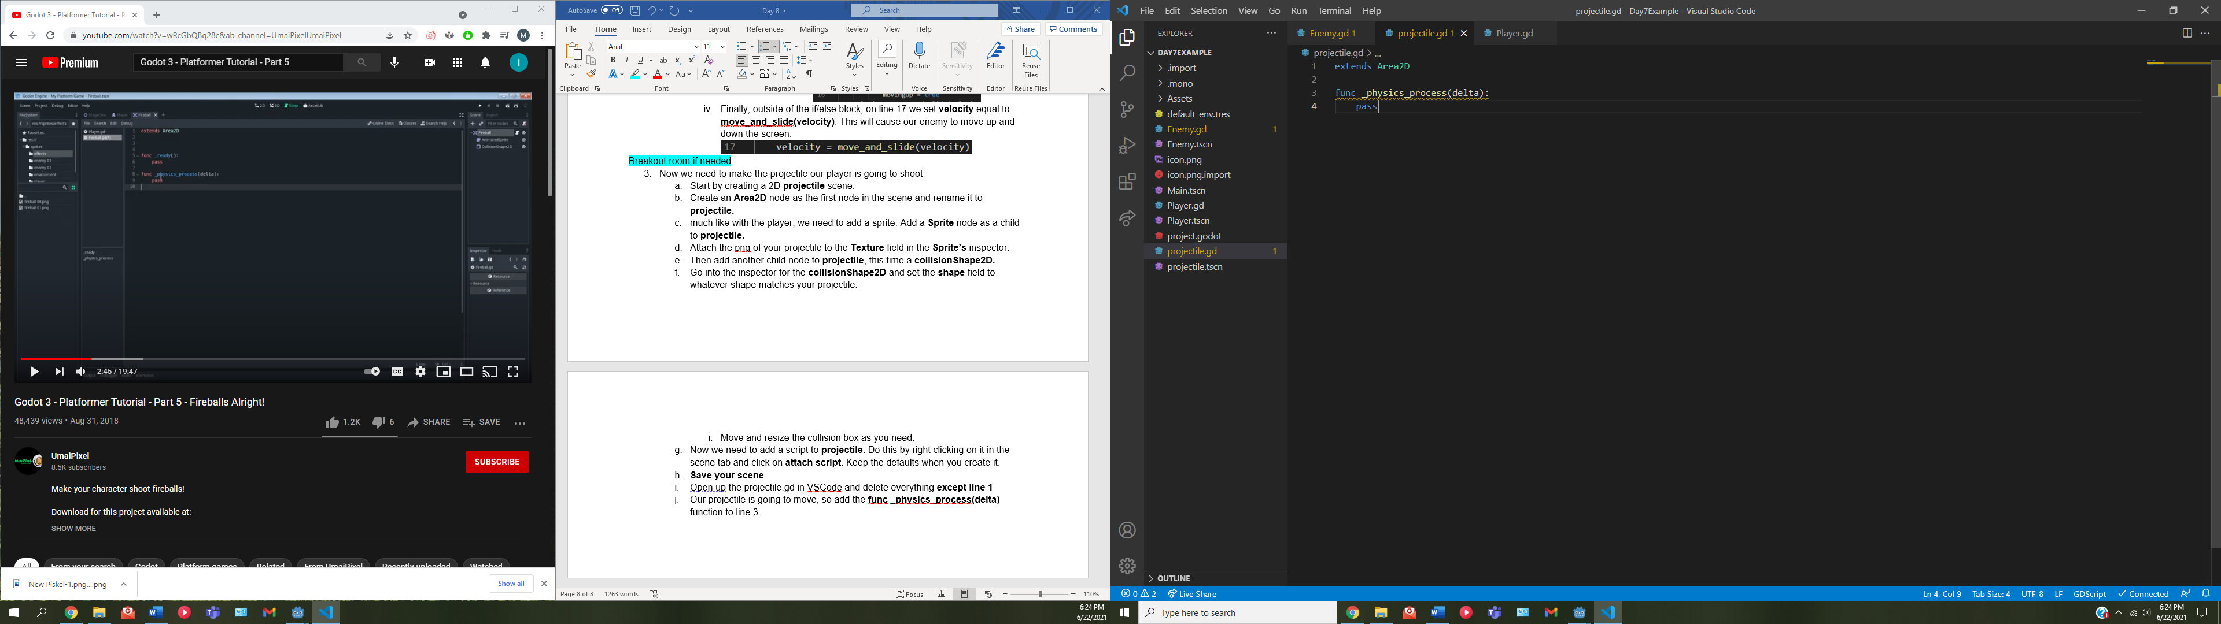

* 1. We need to add some variable to projectile.
     1. First one will be a **const SPEED** that we set to 100. It is made a const since we will likely refer to it more than once and it shouldn’t change.
     2. We also need to add a **velocity** variable that is set to a new **Vector2** like we did in the other scripts.

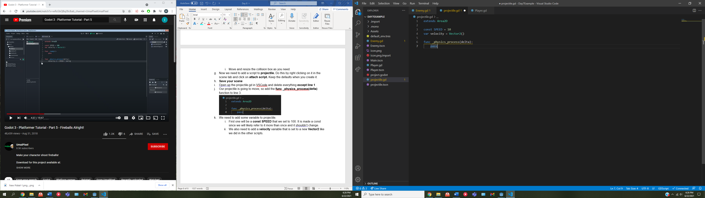

* 1. Then, in our **_physics_process(delta)** function, we need to set the **velocity.x** of our projectile to the **SPEED** times **delta** so it moves in the right direction and speed.

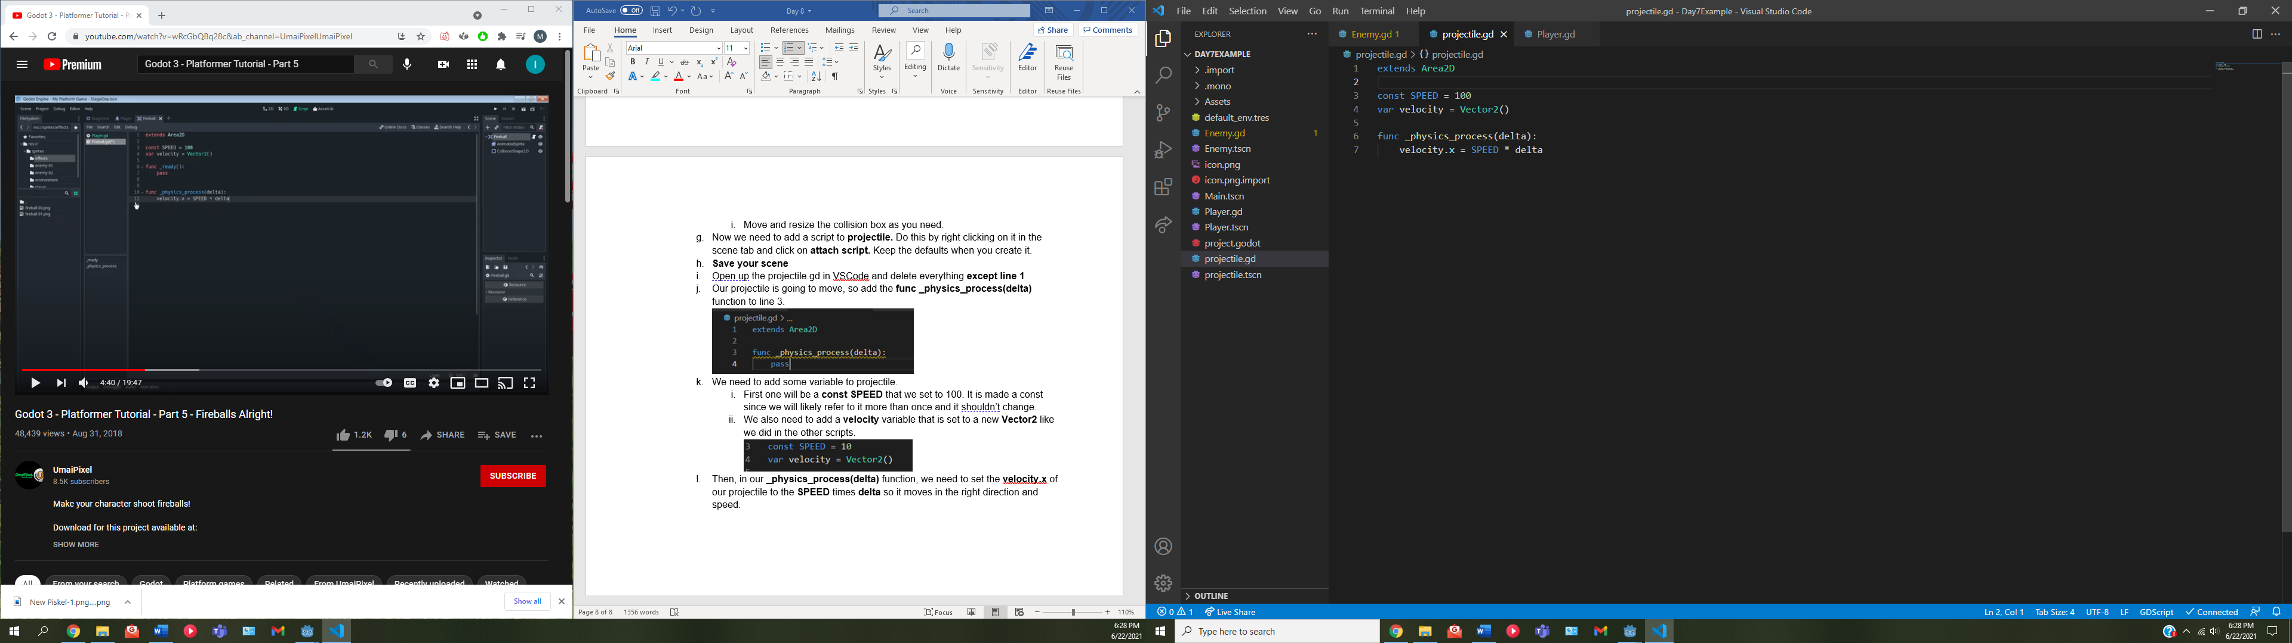

* 1. To get the projectile to move, on line 8 we can call **translate(velocity)** to move our projectile based on the velocity we just calculated.

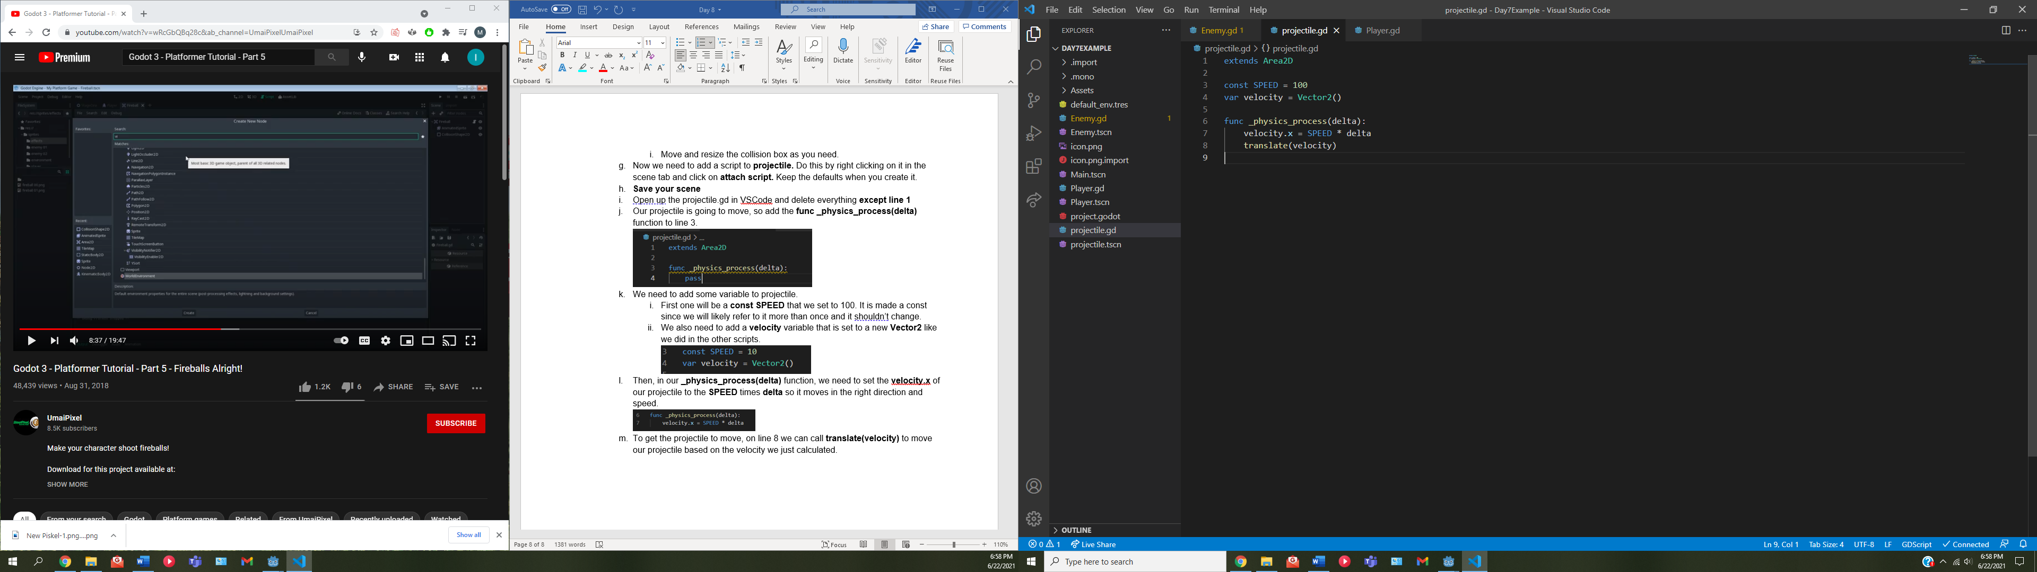

* 1. We should also make sure that our arrows despawn once they are off the screen
     1. To do this, go back into Godot and open the **projectile** scene if it isn’t open already
     2. We want to add a **visibilityNotifier2D** node as a child of **projectile.**
        1. set the orange/red box of the visibility notifier to cover your projectile.
     3. What we then want to do, is in the Node tab, which is right next to the inspector, we need to locate the **screen_exited()** signal

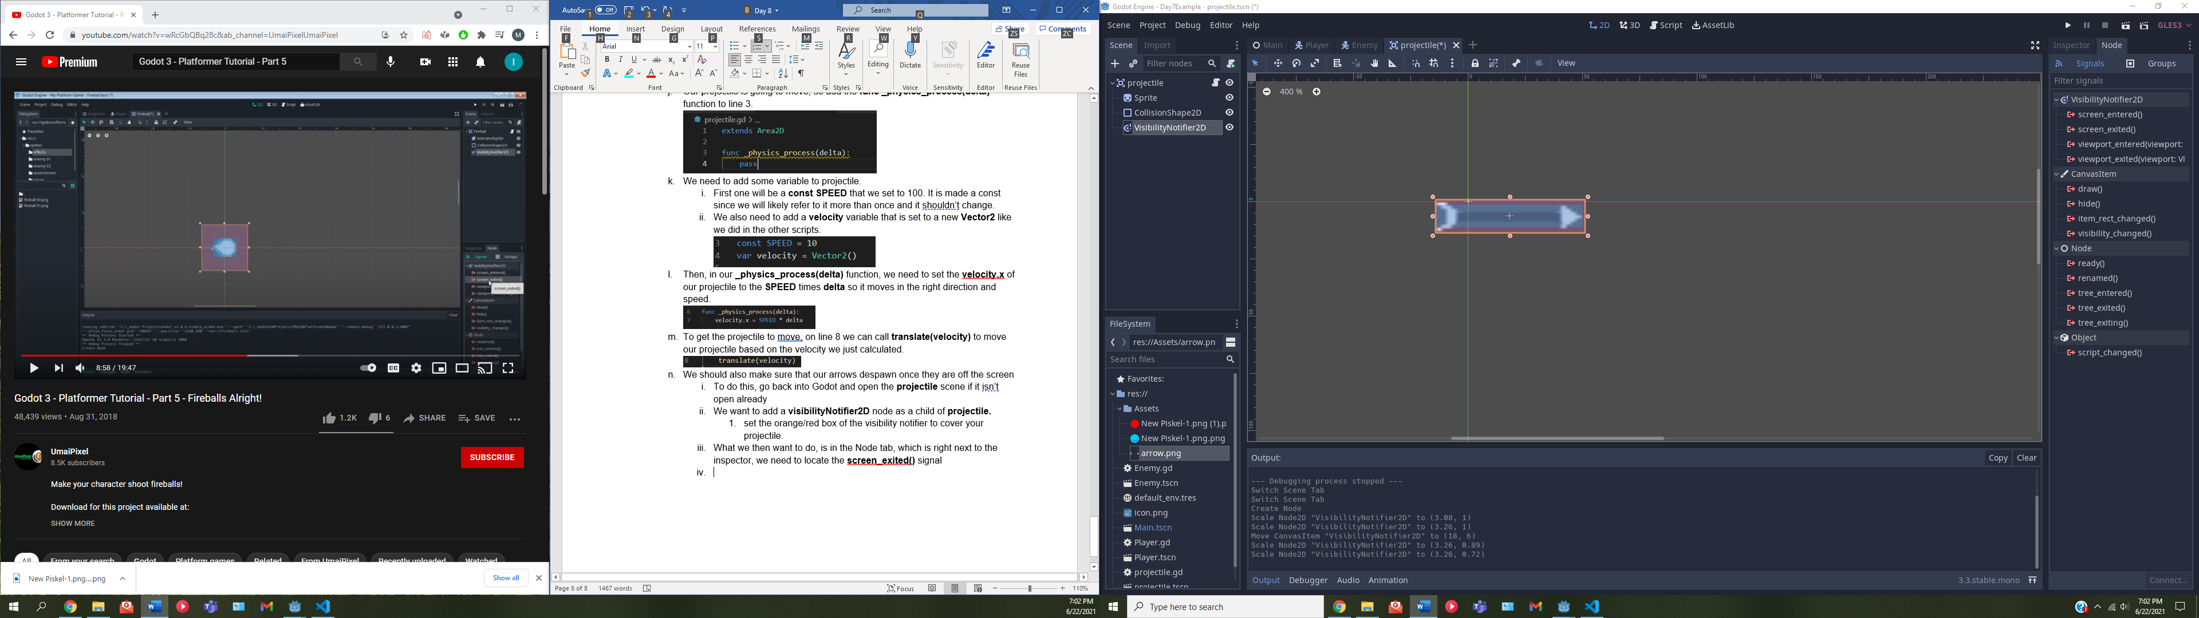

* + 1. We need to make a connection for this signal. Click on it and hit the **connect** button in the bottom right of the Godot screen.
       1. We want the connection to go to the **projectile** and keep the default receiver method. You should see that function appear on the projectile.gd script.
       2. **Be sure to save Godot.**
    2. Open up VSCode again and you should see your **_on_VisibilityNotifier2D_screen_exited()** that was created from the connection.
    3. Remove **pass** from the function and free the queue using the **queue_free()** function. This function basically destroys the object.

Breakout rooms if needed

**Step 4: adding an instance of our projectile to the player**

1. Now we need to open up the **player.gd** script again, since the player is where the projectile is going to source from. Open it up in VSCode
   1. At the top of the **player.gd** add a **const PROJECTILE** and set it to a preload of our projectile scene

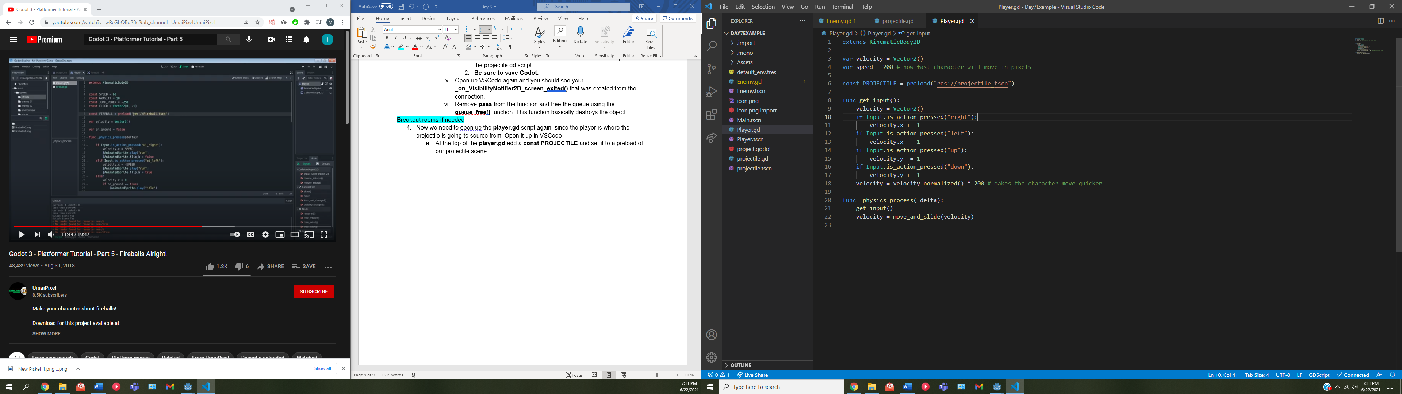

* 1. Then we need to code for the input that shoots the projectile.
     1. Go into Godot and at the very top click on Project -> Project settings -> Input Map (on the dialogue box)
     2. We added some inputs yesterday for movement. Today we’ll add a **“shoot”** action that is triggered with spacebar.
        1. In the **Action** field, type in “shoot” and hit enter.
        2. Now “shoot” should appear towards the bottom of your action list. Click on the plus sign associated with shoot.
        3. Click on **key** and give it the key you wish to use to shoot the projectile. I’ll use space. Hit ok.
     3. Now that we have the input mapped in Godot, **SAVE**, and return to VSCode.
     4. In put **_physics_process(delta)** function, we need to check if the input being pressed is our shoot input. We do this almost the same way we did movement.
     5. Check if the input “is_action_just_pressed” is “shoot” and if it is, create a **projectile** variable that is equal to an instance of our **PROJECTILE** constant.

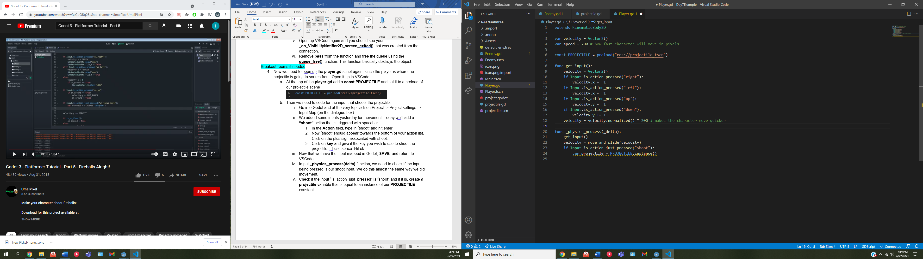

* + 1. Now we need to add the projectile to the scene.
       1. On line 25, get the parent and add a child to it, where the child is the projectile we just created.

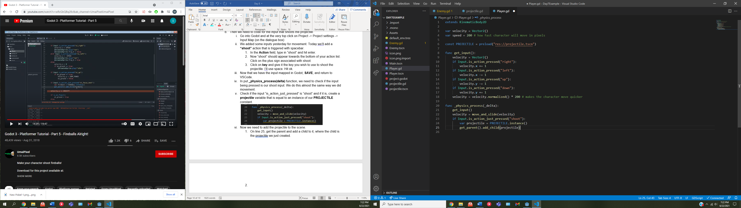

**Step 5: Creating the spawn point of the arrow**

1. Try to run the game now, does that look right? No, the projectile is spawning and moving, but it is coming from the origin of the scene. We need to make it spawn where the player is.
   1. Open up the player scene in Godot.
   2. Add a **Position2D** as a child of **Player**.
   3. Our **position2D** will appear as a crosshair at the top left of our scene. Drag it to wherever you want the projectile to come out of.
   4. Now, save your scene and jump back into VSCode.
   5. On line 26, we need to set the position of the projectile to be the **Position2D** ‘s **global_position.** This will tell it where to spawn.

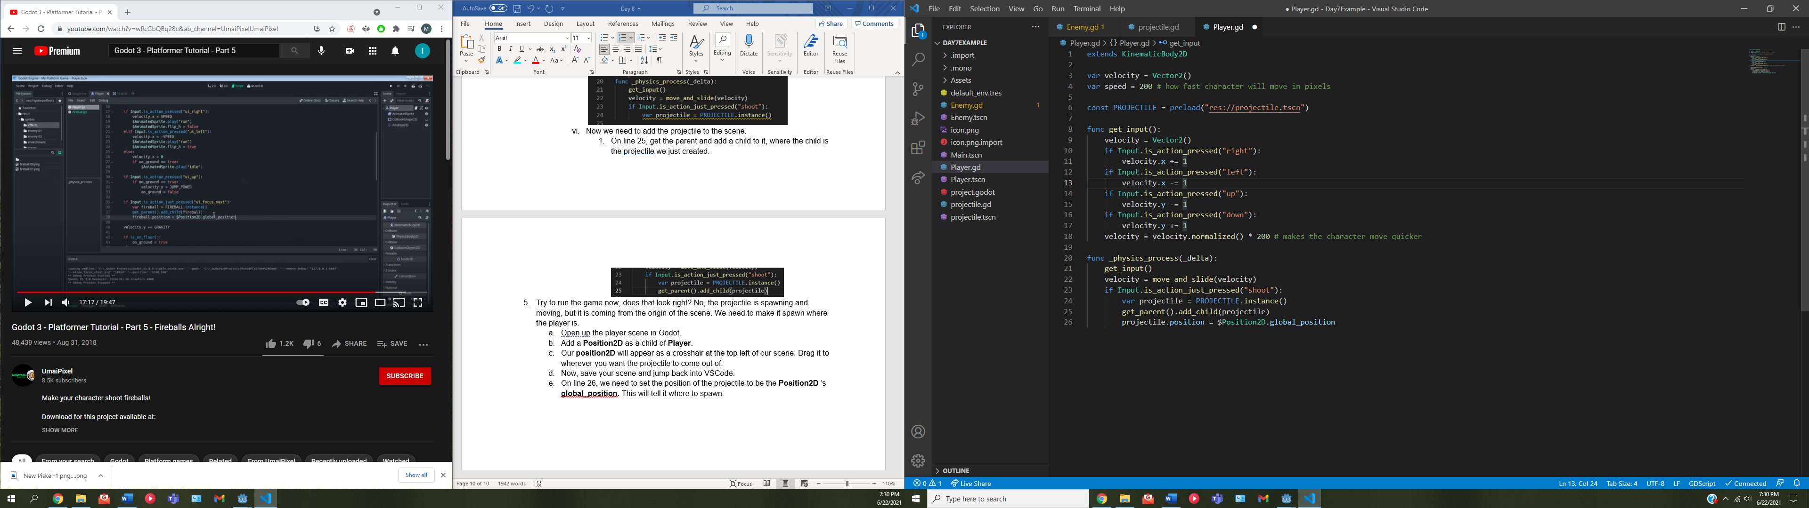

* 1. Now try running the game. The projectile should spawn wherever we put the **position2D.**

Breakout rooms if needed

**Step 6: Having the projectile spawn on the correct side of the player**

1. We now need to make the arrow spawn in the direction of player movement, which means if our character is moving right, and thus facing right, the **Position2D** should be on the right side of the character. Vice-versa for the left. We need to go into the scripts and change that.
   1. Open up the **player.gd** script and locate the **get_input()** function.
   2. Where we check if the player is moving right, right before we increase the velocity, we are going to set the **position.x** of the **$Position2D** to be equal to the right side of the player.
      1. To figure out what position that is, open Godot and in the **Player** scene, open the inspector for the **Position2D.** by default, we set the **position2D** to be on the right side of the player. In the inspector, locate the **Transform** tab and click it to open it.
      2. You should notice an X position. Copy that value. (in my case it is 180.433)
      3. Go back into VSCode and set the **position.x** of the **$Position2D** to be equal to 180.433

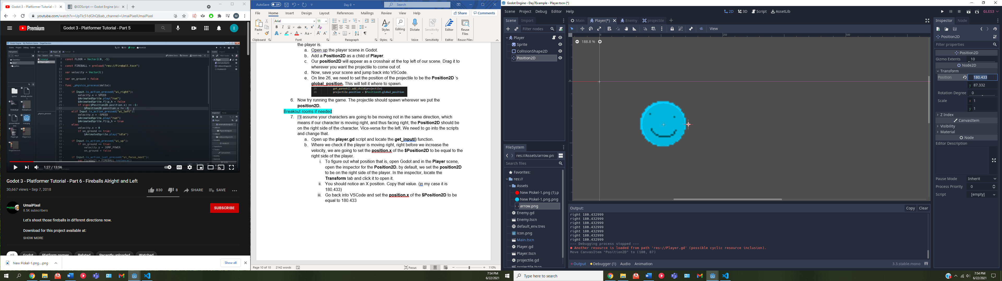

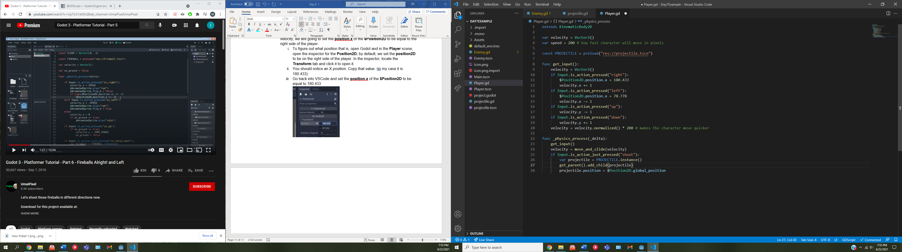

* 1. Now we need to do the same for the left side of the player.
     1. First, we’ll get the X position we’ll be using.
     2. open Godot and in the **Player** scene, click on the **Position2D.** move the **position2D** (the crosshair) to the left side of the player.
     3. Notice in the inspector the X position that we fetched the last time has changed. That’s the value we need. (for me it is 70.778)
     4. Now back in VSCode, where we set the velocity.x whenever the left action is pressed, we need to also set the $**Position2D.position.x** to be equal to the value we fetched.

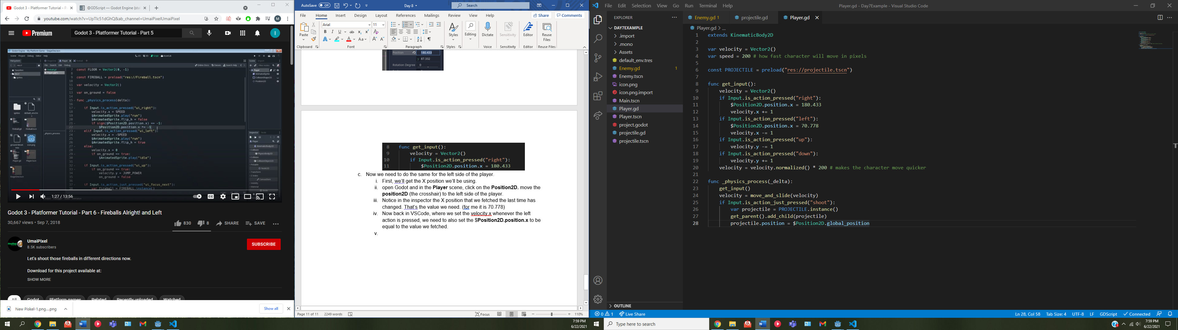

* 1. Few things to note. We need to make sure that the Y position values do not change since we are only changing the X value. Also, before a directional movement action is even pressed, the projectile will fire from wherever we left the **position2D**, so if you didn’t move it back to the right side after fetching the left position, it will fire from the left by default. This isn’t necessarily a problem, but it is something to be wary of.

Breakout rooms if needed

**Step 7: Setting the projectile’s collision and sprite to correct direction**

1. So right now, we have it shooting from both sides, but they are always going in the right direction. Let’s fix that.
   1. In the **projectile.gd** script, we need to add a **direction** variable and have it set to 1. 1 will represent the (directional) right direction.
   2. We then need to create a **func set_direction(dir)** function that we will use to set that variable to the direction we want to.
      1. Inside the function, we need to set **direction = dir** so the value that is passed in becomes our direction, and then check if our new direction is -1 (left).
         1. If it is, we need to set the **scale** of the projectile **(self)** to the inverse of itself **( *= -1 )**. Doing this will flip the sprite and all of its collisions / detections.

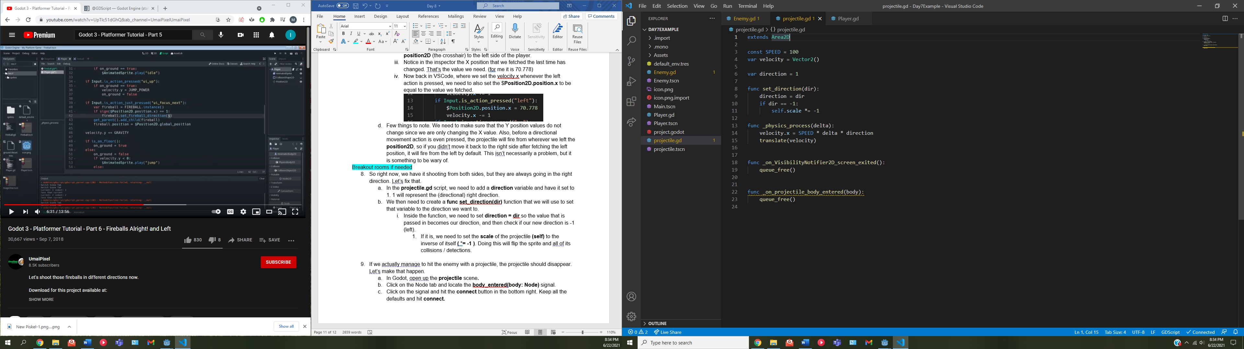

* 1. Once we know what the direction should be, in our **_physics_process(delta)** we need to also multiply our **velocity.x** by our **direction** so the projectile moves in the right direction

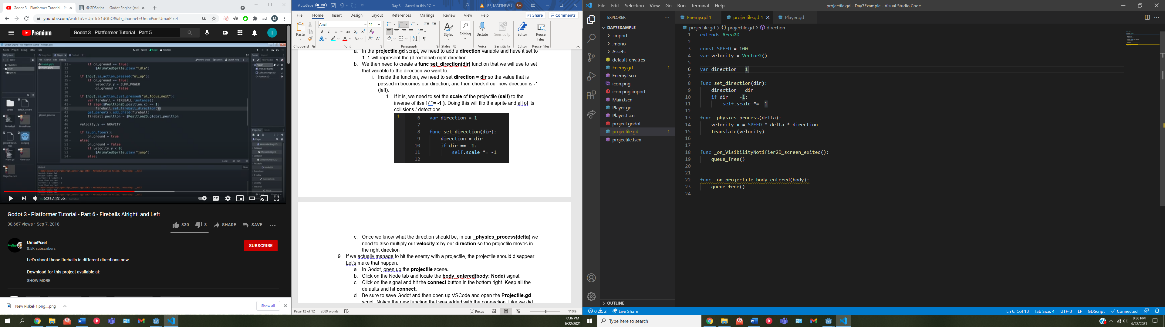

* 1. We aren’t done yet. Now we need to go into the **Player.gd** script so we can actually change the direction of our instanced projectile using the function we just wrote.
     1. Inside **Player.gd** create a **projectile_dir** variable and set it to 1.
     2. Then, in the get_input() function, right after setting the x position of the Position2D, we need to set the **projectile_dir** to be the direction we’re about to move in. remember, 1 is **right** and -1 is **left.**

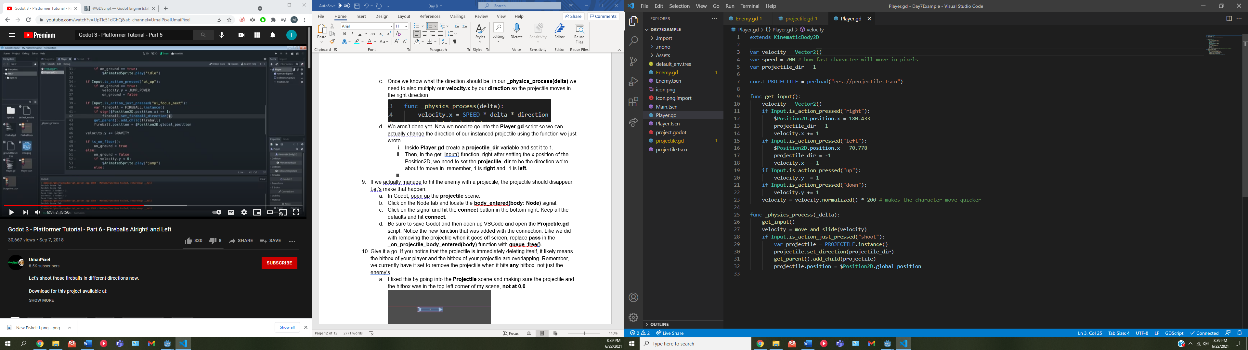



* + 1. Once we have the **projectile_dir** set, in our **_physics_process(delta)** function, right after creating the **projectile** variable, we can call our **set_direction(dir)** on it, passing in the **projectile_dir** variable we just set.

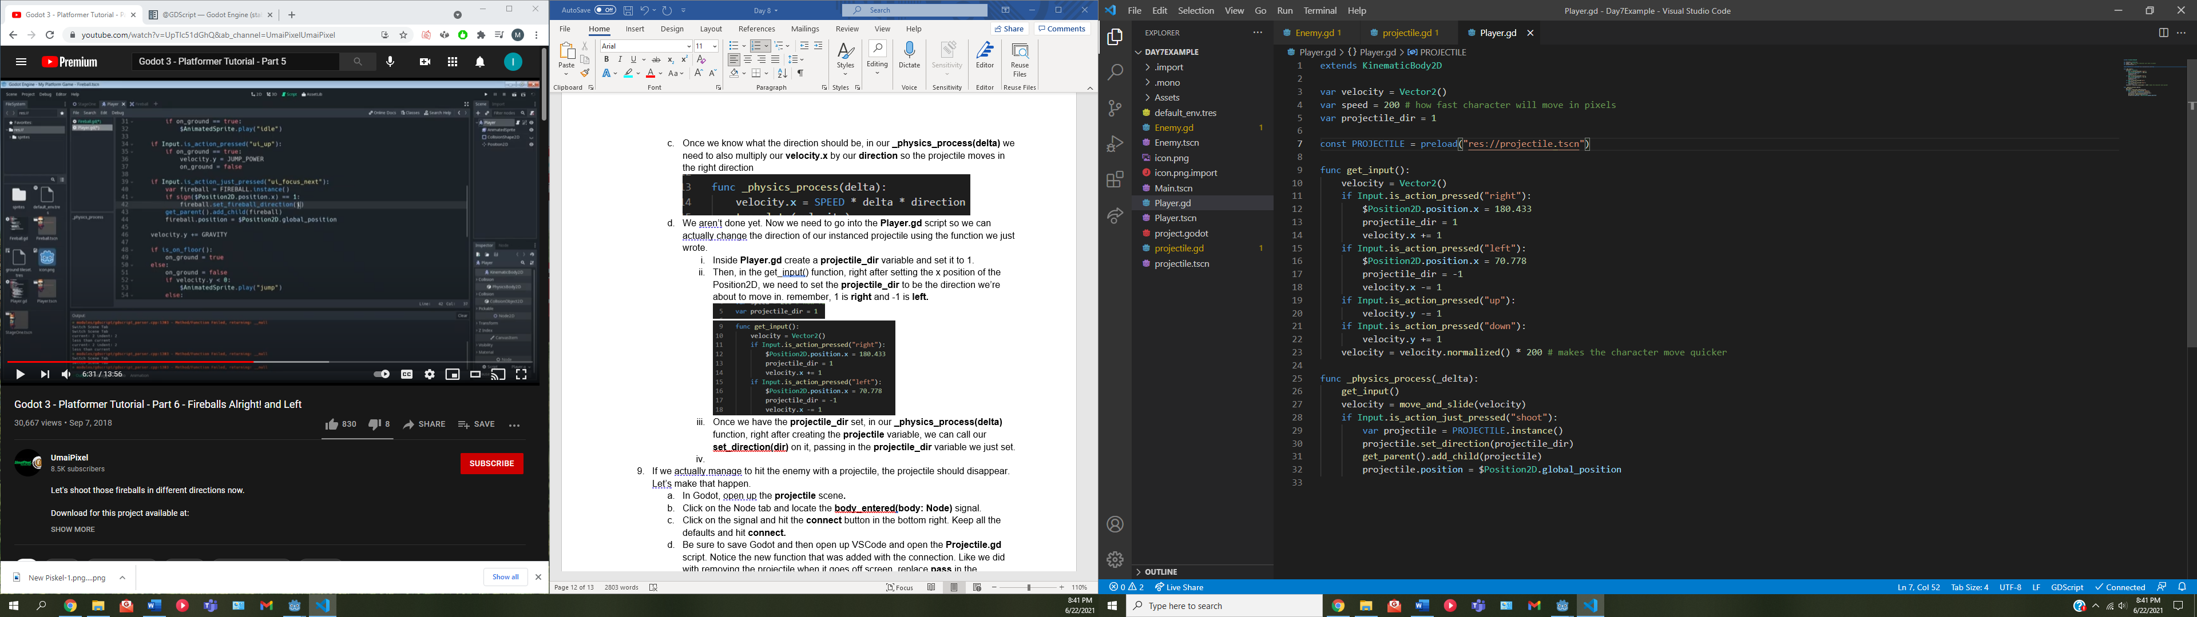

* + 1. This will make sure our arrow moves in the right direction and the sprite is also flipped.

Breakout rooms if needed

**Step 8: Make the arrow disappear when it hits anything**

1. If we actually manage to hit the enemy with a projectile, the projectile should disappear. Let’s make that happen.
   1. In Godot, open up the **projectile** scene**.**
   2. Click on the Node tab and locate the **body_entered(body: Node)** signal.
   3. Click on the signal and hit the **connect** button in the bottom right. Keep all the defaults and hit **connect.**
   4. Be sure to save Godot and then open up VSCode and open the **Projectile.gd** script. Notice the new function that was added with the connection. Like we did with removing the projectile when it goes off screen, replace **pass** in the **_on_projectile_body_entered(body)** function with **queue_free().**
   5. Give it a go. If you notice that the projectile is immediately deleting itself, it likely means the hitbox of your player and the hitbox of your projectile are overlapping. Remember, we currently have it set to remove the projectile when it hits **any** hitbox, not just the enemy’s.
      1. I fixed this by going into the **Projectile** scene and making sure the projectile and the hitbox was in the top-left corner of my scene, **not at 0,0**

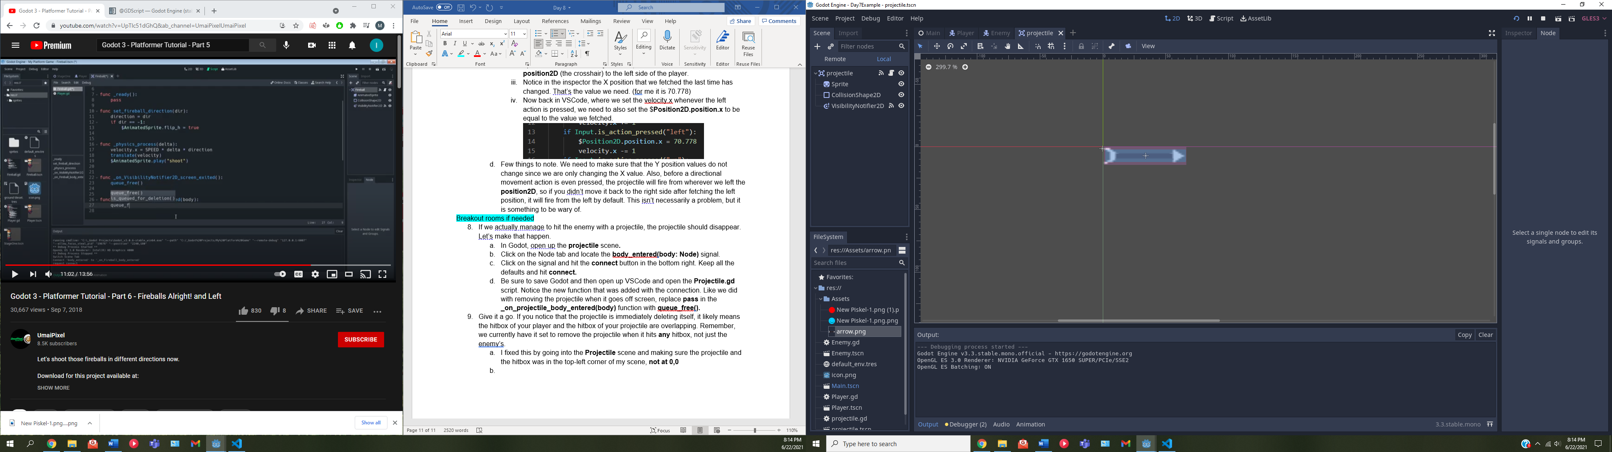

Quick Breakout rooms if needed

**Step 9: Killing the enemy if it is hit with the projectile**

1. Now we need to actually kill the enemy if it is hit.
   1. To do this, open up the **Enemy.gd** script and create an **isDead** variable that is set to **false.**
   2. Then, we need to create a **func dead()** which will be called when the projectile hits the enemy.
      1. Inside the **dead()** function. We need to set **isDead** to **true**
      2. **Velocity** to **Vector2()** (setting the velocity to 0,0)
      3. and call **queue_free()** to “delete” the enemy.

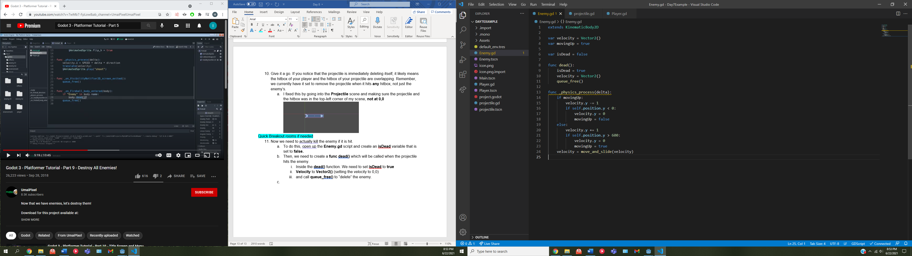

* 1. Now, open up the **projectile.gd** script.
     1. Remember, we already have a function that detects if the projectile has hit something, the **_on_projectile_body_entered(body)** function. The “body” in the parameter is the collision that the projectile just entered.
     2. So, if we check if the “Enemy” is in the name of that body, it means the projectile has entered the collision of an enemy.
        1. If that check is true, call the **dead()** function on the body.

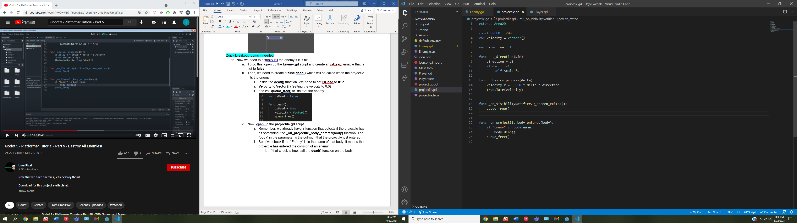

Quick breakout room if needed

**Step 10: Finishing up / Recap**

1. Give what you have a go, the following should take place:
   1. Our enemy should spawn
   2. Out enemy should move up and down
   3. The projectile should shoot from the player
   4. The projectile will shoot from the side of the player corresponding to the direction the player is moving in
   5. If the projectile hits an enemy, the enemy should “die” (disappear) along with its collision.

There’s a lot more to add to this lot, such as animations for all of the above things that were listed. Thankfully, *should* just be a matter of calling a certain animation when it is needed (e.g. play the dead animation in the dead() function)

That should be all for the Godot portion of the day.

Breakout rooms if needed

**ACTIVITY: Game Development**

In your groups, continue working on game brainstorming, asset design, and character movement / attacks.